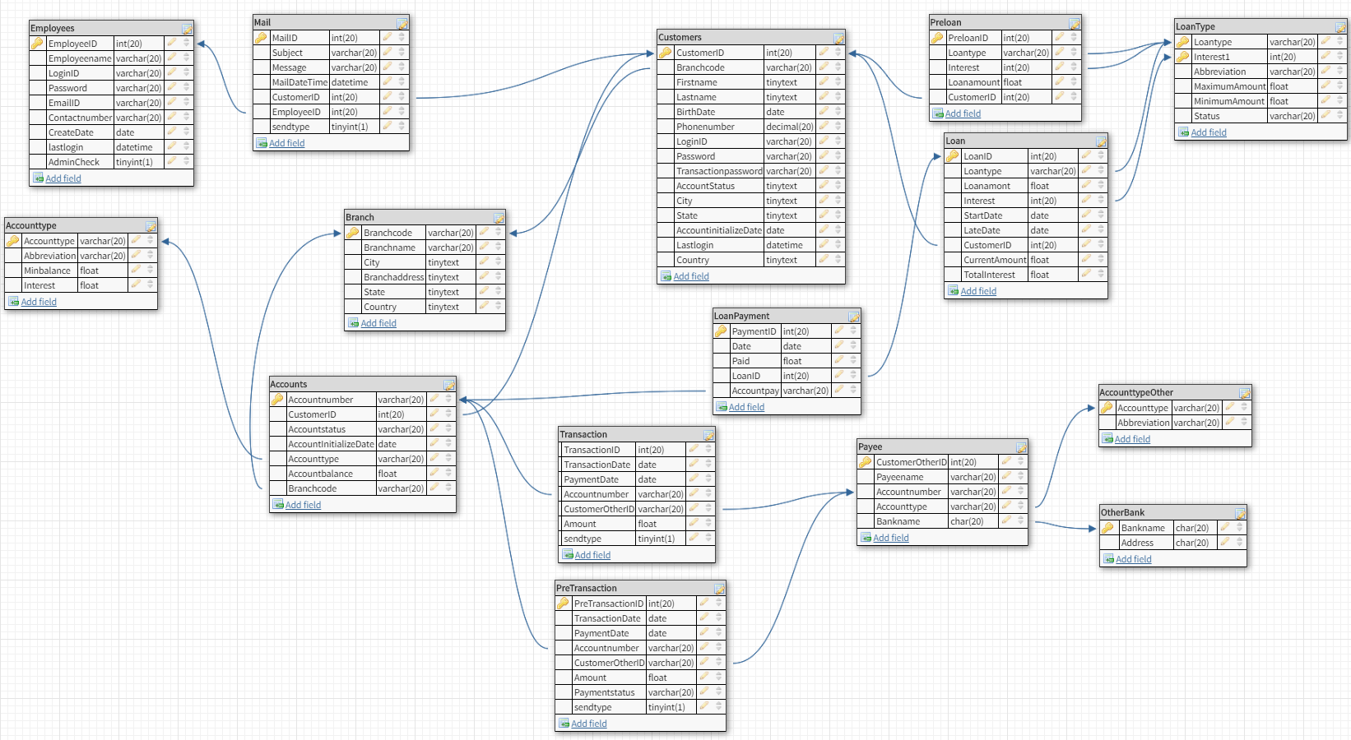ER DIAGRAM 1 – many relationships , Yellow Primary key, Arrow from = Foreign Key